resnet = 1618487444_prefix_test_list_resnet_export_svm.txt  
lstm = 1618487481_prefix_test_list_lstm_export_svm.txt

RESNET

SEQ: 3 -- GT: 0 | max(resnet): 2 >>> [2, 2, 2, 2, 2, 0, 0, 2, 2, 2]

LSTM: [0, 0, 0, 0, 0, 0, 0, 0, 0, 0]

SEQ: 4 -- GT: 0 | max(resnet): 4 >>> [2, 4, 4, 4, 4, 4, 4, 4, 4, 4, 4, 4, 4, 4, 0, 0, 1, 2, 2, 4, 2, 4, 6, 6, 6, 6, 6, 6, 2, 6, 2, 2, 6, 6, 6, 2]

SEQ: 7 -- GT: 1 | max(resnet): 3 >>> [3, 3, 3, 3, 6, 6]

SEQ: 16 -- GT: 3 | max(resnet): 5 >>> [5, 5, 5, 5, 5, 1, 5, 5, 5, 5, 5, 5, 1, 1]

SEQ: 18 -- GT: 3 | max(resnet): 0 >>> [0, 0, 0, 0, 0, 0, 0, 3, 3]

SEQ: 20 -- GT: 3 | max(resnet): 2 >>> [2, 2, 2, 2, 6, 6]

SEQ: 22 -- GT: 3 | max(resnet): 5 >>> [5, 5, 5, 5, 5, 5]

SEQ: 31 -- GT: 4 | max(resnet): 2 >>> [2, 2, 2, 3, 2, 2, 2, 2, 2, 2, 2, 2]

SEQ: 34 -- GT: 5 | max(resnet): 4 >>> [1, 1, 4, 4, 4, 4, 4, 4, 4, 5, 5, 5, 5, 5, 5, 5]

SEQ: 37 -- GT: 5 | max(resnet): 6 >>> [6, 6, 6, 6, 6, 6, 6, 6, 6, 6]

SEQ: 43 -- GT: 6 | max(resnet): 1 >>> [6, 6, 6, 6, 5, 1, 1, 1, 1, 1]

LSTM [6, 6, 6, 6, 6, 6, 6, 6, 6, 6]

SEQ: 47 -- GT: 6 | max(resnet): 3 >>> [3, 5, 5, 5, 3, 3, 3, 3, 3, 3, 3, 3, 3, 3]

LSTM:

SEQ: 1 -- GT: 0 | max(resnet): 3 >>> [3, 3, 3, 3, 3, 3, 3, 3, 3, 3, 3, 3, 3, 3, 3, 3, 3, 3, 3, 3, 3, 3]

RESNET [0, 0, 0, 0, 0, 0, 0, 0, 0, 0, 0, 0, 0, 0, 0, 0, 0, 0, 0, 0, 0, 0]

SEQ: 4 -- GT: 0 | max(resnet): 6 >>> [6, 6, 6, 6, 4, 4, 4, 4, 4, 4, 6, 6, 6, 6, 6, 6, 6, 6, 6, 6, 6, 6, 6, 6, 6, 6, 6, 6, 6, 6, 6, 6, 6, 6, 6, 6]

SEQ: 7 -- GT: 1 | max(resnet): 3 >>> [3, 3, 3, 3, 3, 3]

SEQ: 10 -- GT: 2 | max(resnet): 0 >>> [0, 0, 0, 0, 0, 0, 0, 0, 0, 0, 2, 0, 0, 0, 0, 0, 0, 0, 0, 0, 0, 0, 0, 0]

RESNET [2, 2, 2, 2, 2, 2, 2, 2, 2, 2, 2, 2, 2, 2, 2, 2, 2, 2, 2, 2, 2, 2, 2, 2]

SEQ: 16 -- GT: 3 | max(resnet): 1 >>> [1, 1, 1, 1, 1, 1, 1, 1, 1, 1, 1, 1, 1, 1]

SEQ: 18 -- GT: 3 | max(resnet): 0 >>> [0, 0, 0, 0, 0, 0, 0, 0, 0]

SEQ: 20 -- GT: 3 | max(resnet): 6 >>> [6, 6, 6, 6, 6, 6]

SEQ: 22 -- GT: 3 | max(resnet): 5 >>> [5, 5, 5, 5, 5, 5]

SEQ: 31 -- GT: 4 | max(resnet): 2 >>> [2, 2, 2, 3, 3, 2, 2, 2, 2, 2, 2, 2]

SEQ: 34 -- GT: 5 | max(resnet): 4 >>> [1, 1, 1, 4, 4, 4, 4, 4, 4, 4, 4, 4, 4, 5, 5, 5]

SEQ: 37 -- GT: 5 | max(resnet): 6 >>> [5, 5, 5, 6, 6, 6, 6, 6, 6, 6]

SEQ: 44 -- GT: 6 | max(resnet): 3 >>> [3, 3, 3, 3, 3, 3, 3, 3, 3, 3, 6, 6, 6, 6, 6, 6, 6, 6]

RESNET [3, 3, 3, 3, 3, 3, 6, 6, 6, 6, 6, 6, 6, 6, 6, 2, 2, 2]

SEQ: 47 -- GT: 6 | max(resnet): 3 >>> [3, 5, 5, 5, 5, 5, 3, 3, 3, 3, 3, 3, 3, 3

SEQ: 0 -- GT: 0 | max(resnet): 3 >>> ['0', '0', '0', '0', '3', '3', '3', '3', '3', '3', '3', '3']

SEQ: 6 -- GT: 1 | max(resnet): 4 >>> ['4', '4', '4', '4', '4', '6', '5', '6']

SEQ: 7 -- GT: 1 | max(resnet): 6 >>> ['6', '6', '6', '6', '6', '6']

SEQ: 16 -- GT: 3 | max(resnet): 1 >>> ['1', '1', '1', '1', '1', '1', '1', '1', '1', '1', '1', '1', '1', '1']

SEQ: 19 -- GT: 3 | max(resnet): 0 >>> ['0', '0', '0', '0', '0', '0']

SEQ: 25 -- GT: 3 | max(resnet): 2 >>> ['2', '2', '3', '2', '6', '3', '3']

SEQ: 30 -- GT: 4 | max(resnet): 0 >>> ['0', '0', '3', '0', '3', '0', '0']

SEQ: 31 -- GT: 4 | max(resnet): 2 >>> ['2', '2', '2', '2', '2', '2', '2', '3', '4', '2', '2', '2']

SEQ: 47 -- GT: 6 | max(resnet): 3 >>> ['5', '3', '3', '3', '3', '3', '3', '6', '6', '6', '6', '2', '5', '5']

SEQ: 2 -- GT: 0 | max(resnet): 3 >>> ['3', '3', '3', '3', '3', '3', '3', '3', '3', '3', '3', '3', '3', '3', '3', '3', '3', '3', '3', '3', '3', '3', '3', '3']

SEQ: 6 -- GT: 1 | max(resnet): 4 >>> ['4', '4', '4', '4', '4', '4', '4', '4']

SEQ: 7 -- GT: 1 | max(resnet): 6 >>> ['6', '6', '6', '6', '6', '6']

SEQ: 16 -- GT: 3 | max(resnet): 1 >>> ['1', '1', '1', '1', '1', '1', '1', '1', '1', '1', '1', '1', '1', '1']

SEQ: 19 -- GT: 3 | max(resnet): 0 >>> ['0', '0', '0', '0', '0', '0']

SEQ: 25 -- GT: 3 | max(resnet): 2 >>> ['3', '2', '2', '2', '6', '6', '3']

SEQ: 30 -- GT: 4 | max(resnet): 0 >>> ['0', '0', '3', '3', '3', '0', '0']

SEQ: 31 -- GT: 4 | max(resnet): 2 >>> ['2', '2', '2', '2', '2', '2', '2', '2', '2', '6', '2', '2']

SEQ: 47 -- GT: 6 | max(resnet): 3 >>> ['3', '3', '3', '3', '3', '3', '3', '3', '3', '3', '3', '3', '3', '3']

SEQ: 3 -- GT: 0 | max(resnet): 2 >>> ['2', '2', '2', '2', '2', '2', '2', '2', '2', '2']

SEQ: 9 -- GT: 1 | max(resnet): 0 >>> ['0', '0', '0', '0', '0', '0', '0', '0', '0', '0', '0', '0', '1']

SEQ: 10 -- GT: 2 | max(resnet): 6 >>> ['6', '6', '6', '6', '6', '2', '2', '6', '6', '6', '6', '6', '6', '6', '6', '6', '6', '6', '6', '6', '6', '6', '6', '2']

SEQ: 33 -- GT: 5 | max(resnet): 6 >>> ['6', '6', '6', '6', '6', '6', '6', '6', '6', '6', '6', '6', '5', '5', '5', '5', '5', '5']

SEQ: 34 -- GT: 5 | max(resnet): 1 >>> ['1', '1', '1', '1', '1', '1', '1', '1', '4', '5', '5', '5', '5', '5', '5', '5']

SEQ: 37 -- GT: 5 | max(resnet): 3 >>> ['3', '3', '3', '3', '3', '3', '5', '5', '5', '5']

resnet:

Seq: 16

gt 3

[5, 5, 5, 5, 5, 1, 5, 5, 5, 5, 5, 5, 1, 1]

../../DualBiSeNet/KITTI-360_warped/test.prefix/data_2d_raw/2013_05_28_drive_0004_sync/image_00/data_rect/0000003576.001.png

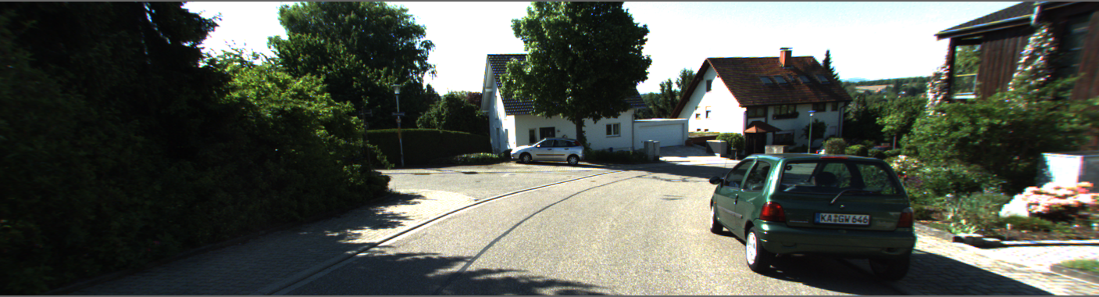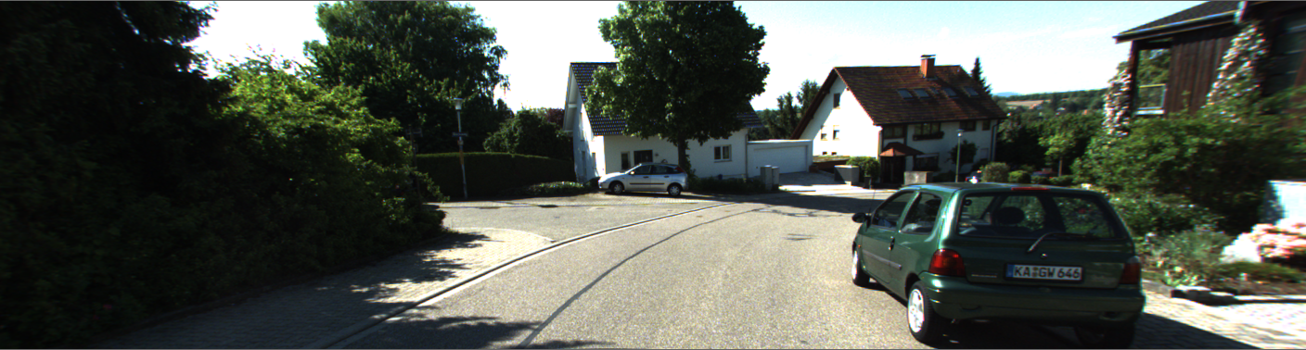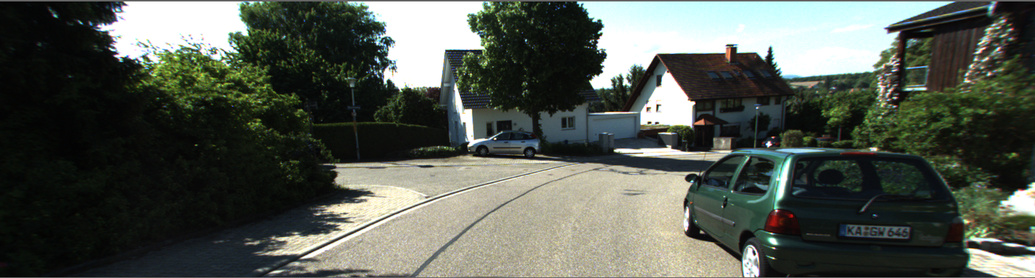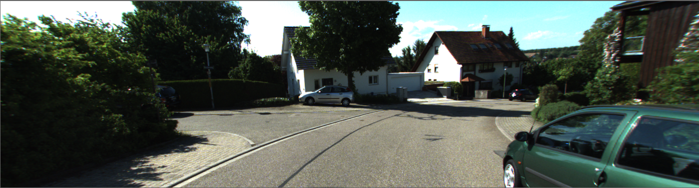

seq 43, resnet

[6, 6, 6, 6, 5, 1, 1, 1, 1, 1] lstm: [6, 6, 6, 6, 6, 6, 6, 6, 6, 6]

../../DualBiSeNet/KITTI-360_warped/test.prefix/data_2d_raw/2013_05_28_drive_0000_sync/image_00/data_rect/0000002446.001.png

6

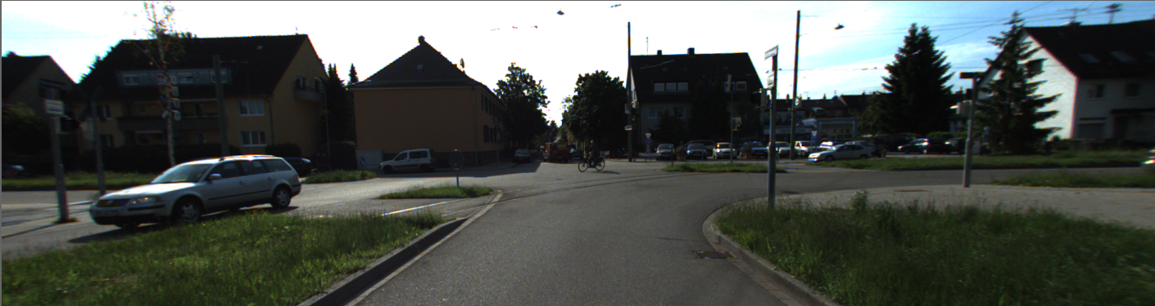

5

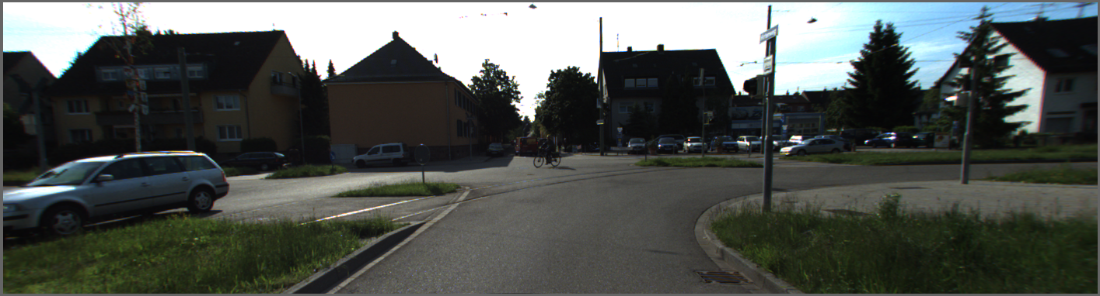

1

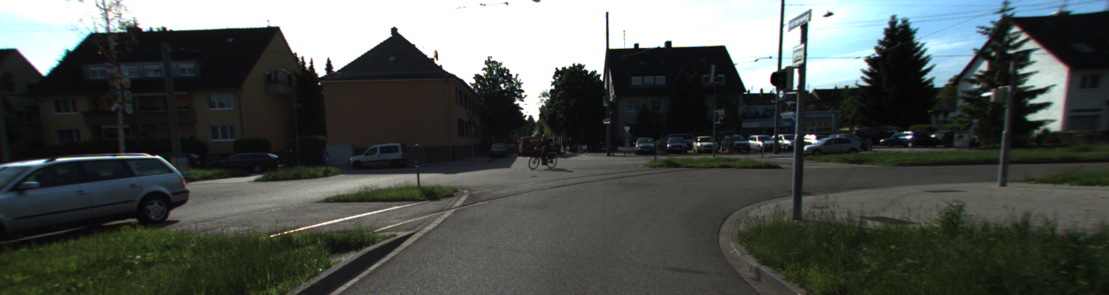

seq 47, gt 6

SEQ: 47 -- GT: 6 | max(resnet): 3 >>> [3, 5, 5, 5, 3, 3, 3, 3, 3, 3, 3, 3, 3, 3]

../../DualBiSeNet/KITTI-360_warped/test.prefix/data_2d_raw/2013_05_28_drive_0006_sync/image_00/data_rect/0000003653.001.png

3

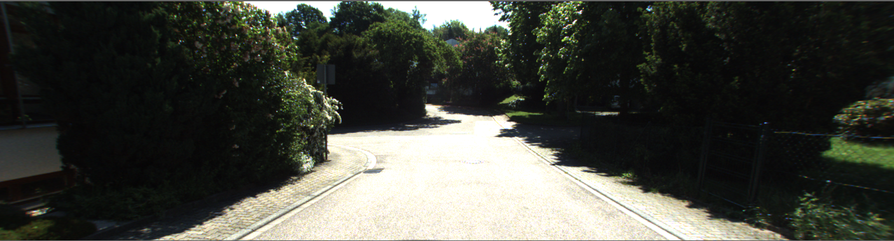

5

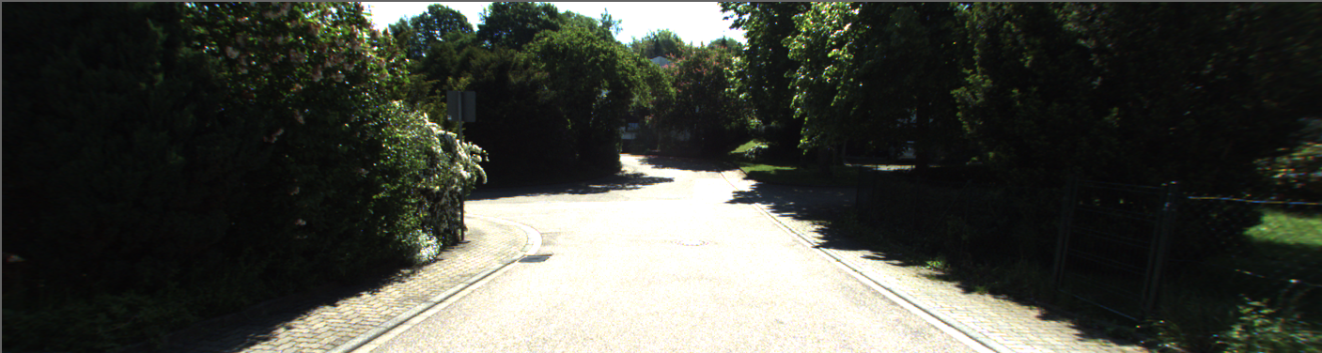

3

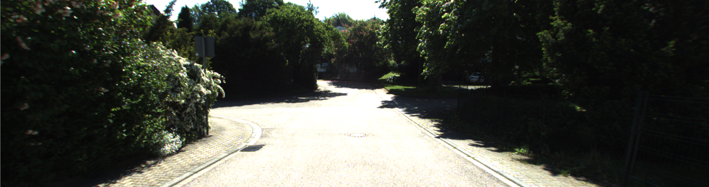

????????????????????????????????????

SEQ: 37 -- GT: 5 | max(resnet): 6 >>> [6, 6, 6, 6, 6, 6, 6, 6, 6, 6]

../../DualBiSeNet/KITTI-360_warped/test.prefix/data_2d_raw/2013_05_28_drive_0004_sync/image_00/data_rect/0000005304.001.png

first

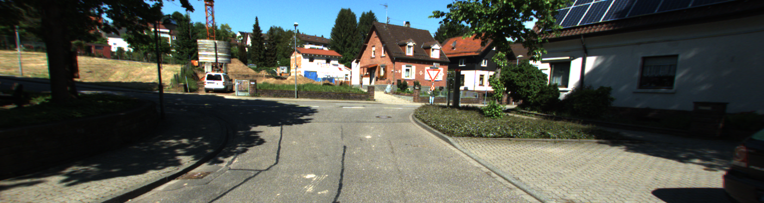

last

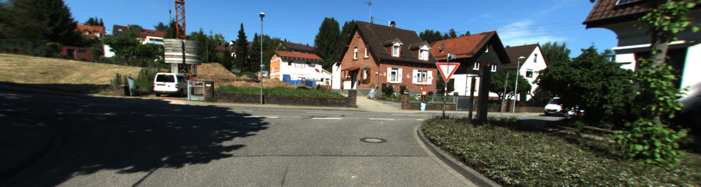

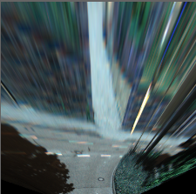

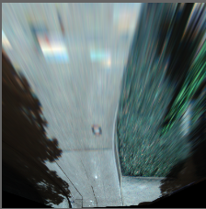

seq 4

gt = 0

[2, 4, 4, 4, 4, 4, 4, 4, 4, 4, 4, 4, 4, 4, 0, 0, 1, 2, 2, 4, 2, 4, 6, 6, 6, 6, 6, 6, 2, 6, 2, 2, 6, 6, 6, 2]

../../DualBiSeNet/KITTI-360_warped/test.prefix/data_2d_raw/2013_05_28_drive_0004_sync/image_00/data_rect/0000005693.001.png

2

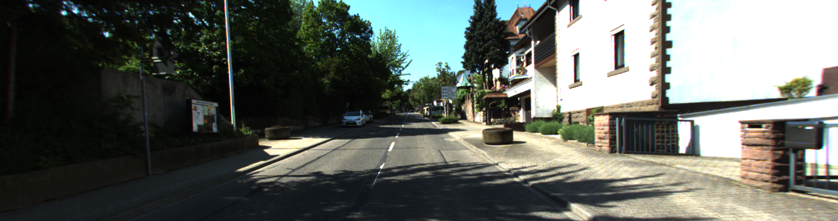

4

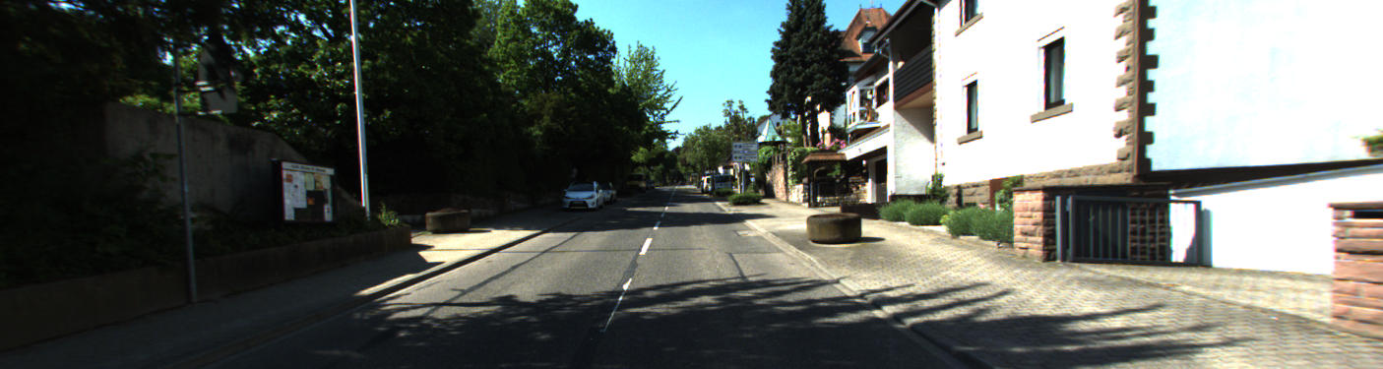

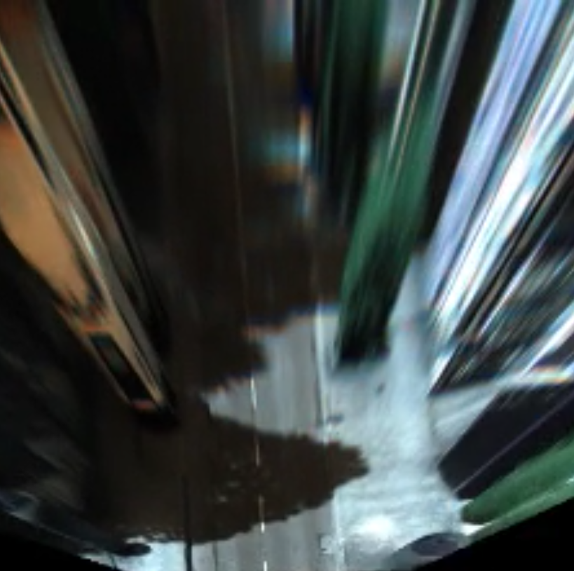

../../DualBiSeNet/KITTI-360_warped/test.prefix/data_2d_raw/2013_05_28_drive_0005_sync/image_00/data_rect/0000006549.001.png

seq 7

gt 1

[3, 3, 3, 3, 6, 6]

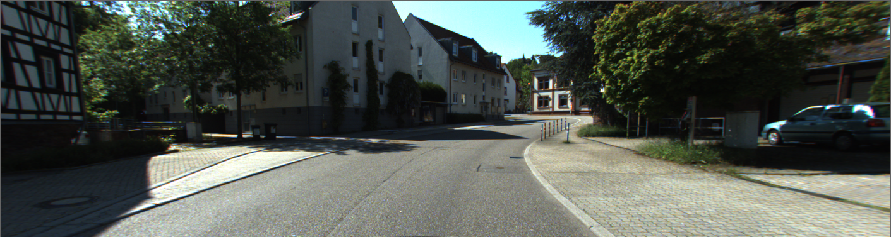

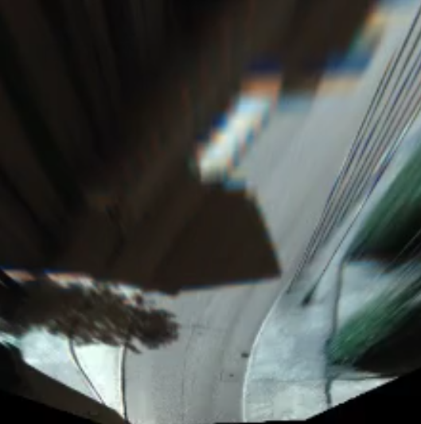

seq 18

gt=3

['0', '0', '0', '0', '0', '0', '0', '3', '3']

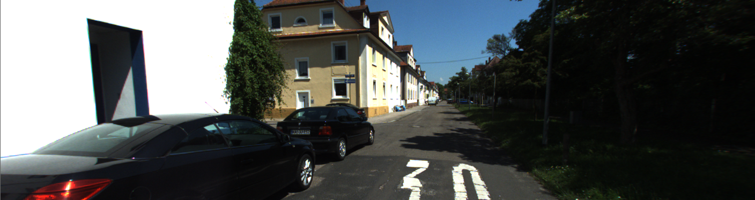

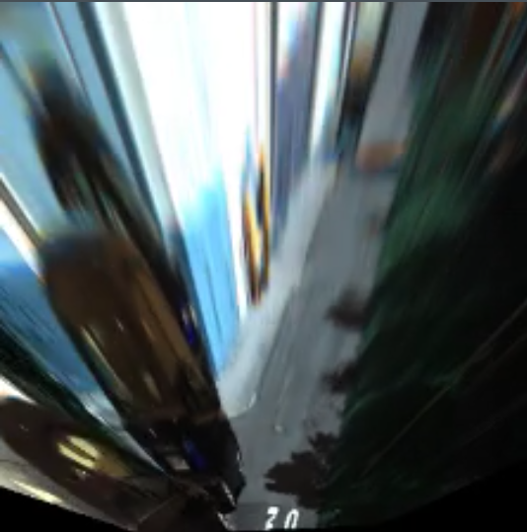

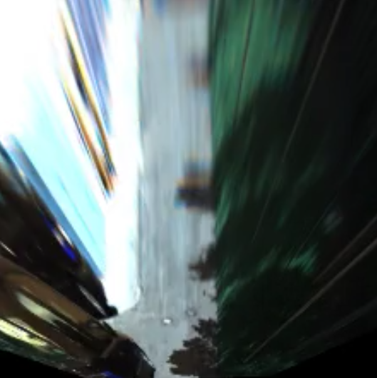

seq 20

['2', '2', '2', '2', '6', '6']

first

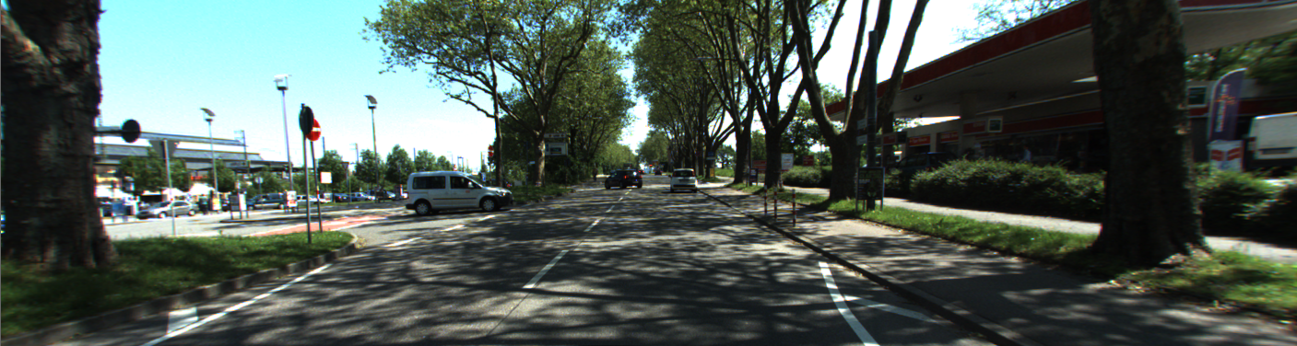

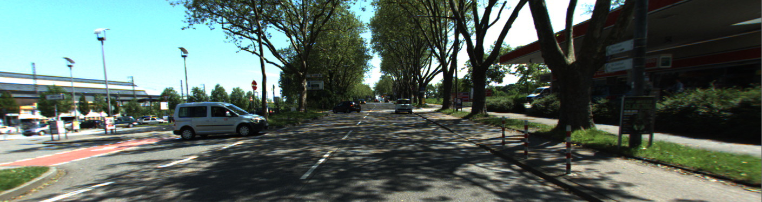

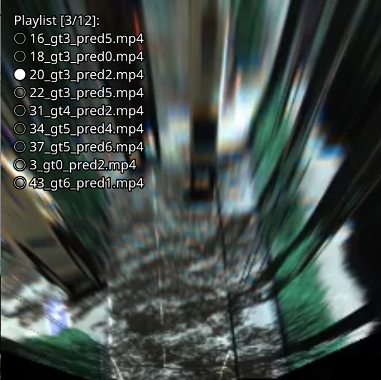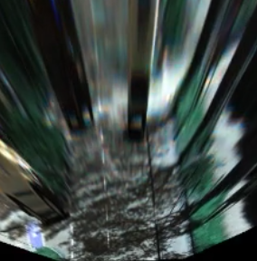

SEQ: 22 -- GT: 3 | max(resnet): 5 >>> [5, 5, 5, 5, 5, 5]

'../../DualBiSeNet/KITTI-360_warped/test.prefix/data_2d_raw/2013_05_28_drive_0002_sync/image_00/data_rect/0000007005.001.png'

first

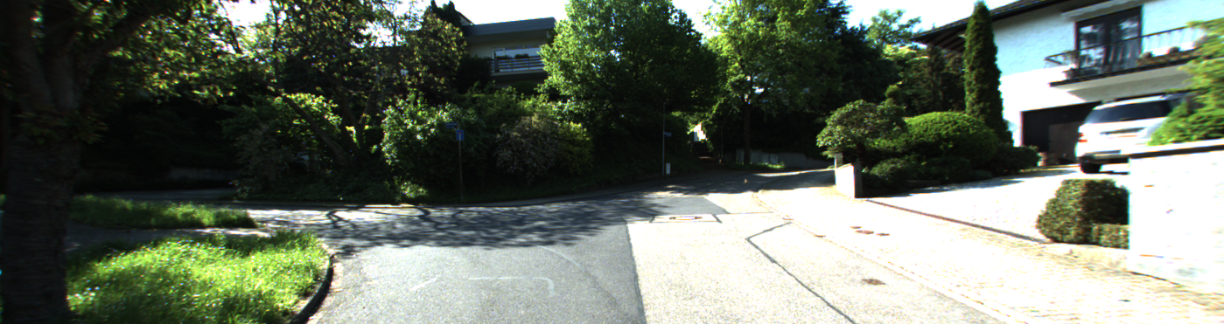

last



